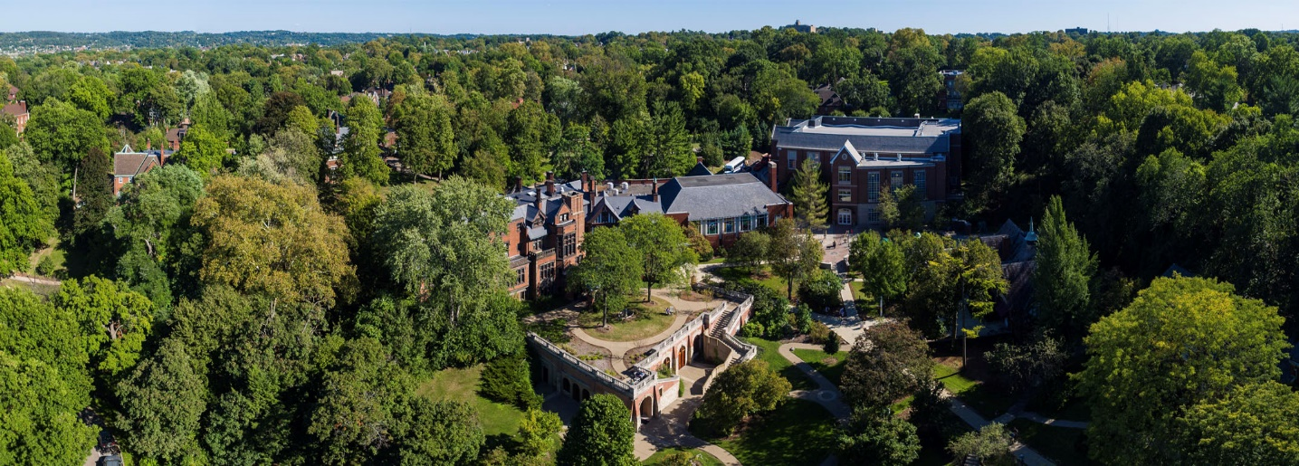
Interested in learning about Chatham University?
********************
- Chatham & BW have articulation agreements
- Graduate programs include DPT, OT, MSAT

Meet Jacob Cribbs, Graduate Admissions Recruiter
Thursday, October 27th
Stop by between 11:00 am – 12:30 pm
Lou Higgins, Tressel Lounge, 2nd floor

Chatham University prepares its students to build lives of purpose, value, and fulfilling work. Through professional skill development and liberal arts learning, Chatham prepares its graduates to be informed and engaged citizens in their communities; to recognize and respect diversity of culture, identity, and opinion; and to live sustainably.
To this end, our work in and out of the classroom prizes our core values of sustainability; women's leadership and gender equity; community engagement; and diversity and inclusion.

Jacob Cribbs • 412-365-1394 • j.cribbs@chatham.edu

