**CITY OF BEREA OHIO**

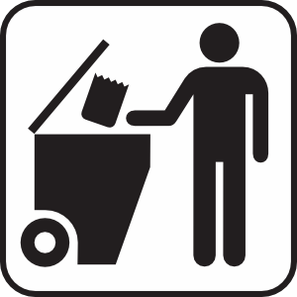

**Where do I store my trash cans?**

* Except when placed on the curbside for collection your trash and recycling containers **must** be stored behind the front building set back line **(behind the front of your house).**
* Receptacles must also be substantially screened from the public.

1. For example, this can be achieved simply by storing your cans in a manner and far enough back from your front building line so they are not readily visible from most angles There are also many other creative and acceptable ways to comply.

* You must also be aware that containers **cannot** be taken out to the curbside until 4:30 pm the night before and **cannot** be left on the curbside past 10:00 am on the day following your regularly scheduled pickup. Placement times would apply to Bulk Waste also